Activity Sheets
Enzymes and Their Functions: Lock-and-Key Activity
A. Lock-and-Key Model

Objective: The objective of this activity is to introduce the concept of enzymes
and their functions through a lock-and-key model by using real locks and keys as
an analogy.
Procedure - Part 1.1:
1. Set 1 of locks and keys will be provided by your teacher.
2. Try all keys with all locks and answer the following questions about Set 1 of
locks/keys.
a. Were you able to open all locks? ________________________________
b. Do all keys open all locks? _____________________________________
c. Can 1 key open more than 1 lock? _______________________________
d. Can you open the same lock with the same key more than once? _______
e. Do all keys have the same shape? _______________________________
Procedure - Part 1.2:
1. A new set of locks/keys (Set 2) will be provided by your teacher.
2. From the previous observations, make 3 predictions about Set 2 of
locks/keys. Hint: Think about the specificity and reusability of the keys, and
about the shape of the locks/keys.
PREDICTIONS:
a. _________________________________________________________
b. _________________________________________________________
c. _________________________________________________________
3. Test your predictions and say if whether or not each prediction was valid
based on the results.
Were your predictions made for Set 2 of locks/keys valid?
______________________________________________________________
4. Make 3 observations of Set 2 of locks/keys.
OBSERVATIONS:
a. _________________________________________________________
b. _________________________________________________________
c. _________________________________________________________
5. Make comparisons between enzymes/substrates and keys/locks (3
similarities and 3 differences).
SIMILARITIES: DIFFERENCES
a. ___________________________ ___________________________
b. ___________________________ ___________________________
c. ___________________________ ___________________________

6. Share your similarities/differences with the classroom (your teacher will keep
track of these in the blackboard).

Activity Sheets
Enzymes and Their Functions: Lock-and-Key Activity
B. Enzymes and Their Functions – Questions
1. Match the following words with their definitions.

1. Match the following words with their definitions.

______ Product
______ Active site
______ Enzymes
______ Catalyst
______ Substrate
______ Activation energy

a. Amount of energy required for a
chemical reaction to occur.
b. Substances that bring about a
chemical reaction without being
changed itself.
c. Substance that enzymes act upon.
d. Regions on the surface of enzymes
that fit the substrate.
e. Substance formed from the substrate
at the end of a chemical reaction with
an enzyme.
f. Proteins that speed up chemical
reactions.

2. Characteristics of enzymes
a. One characteristic of enzymes is that they are reusable. This is important
because ________________________________________________________
b. Name other 3 characteristics of enzymes:
1. _________________________________________________________
2. _________________________________________________________
3. _________________________________________________________
3. Naming enzymes
a. Enzymes names end with__________________________________________
Examples_______________________________________________________
b. Enzymes are named after__________________________________________
Examples ______________________________________________________
4. Fill in the blanks with the appropriate name.
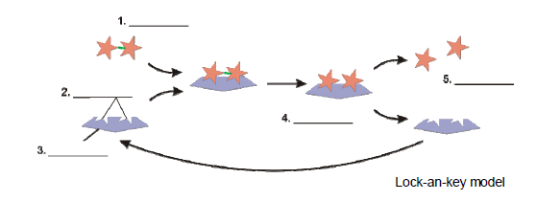
Names: product, active site, enzyme, substrate, enzyme-substrate complex.

